# Ex No: 2

# Date:

# IMPLEMENT A LEXICAL ANALYZER TO COUNT THE NUMBER OF WORDS USING LEX TOOL

**AIM:**

To implement the program to count the number of words in a string using LEX tool.

**STUDY:**

Lex is a tool in lexical analysis phase to recognize tokens using regular expression. Lex tool itself is a lex compiler.

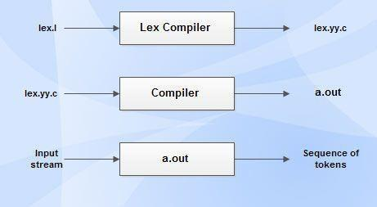

* lex.l is an a input file written in a language which describes the generation of lexical analyzer. The lex compiler transforms lex.l to a C program known as lex.yy.c.
* lex.yy.c is compiled by the C compiler to a file called a.out.
* The output of C compiler is the working lexical analyzer which takes stream of input characters and produces a stream of tokens.
* yylval is a global variable which is shared by lexical analyzer and parser to return the name and an attribute value of token.
* The attribute value can be numeric code, pointer to symbol table or nothing.
* Another tool for lexical analyzer generation is Flex.

# STRUCTURE OF LEX PROGRAMS:

Lex program will be in following form declarations

%%

translation rules

%%

auxiliary functions

**ALGORITHM:**

* Declare necessary header files and variables in the beginning.
* Define rules in the form of regular expressions to identify words and newline characters.
* Increment a counter each time a word is matched.
* Reset the counter when encountering a newline character and print the count.
* Implement the main function to initiate lexical analysis and return 0.

**PROGRAM:**

%{

#include<stdio.h>

#include<string.h>

int i = 0;

%}

/* Rules Section*/

%%

([a-zA-Z0-9])* {i++;} /* Rule for counting

number of words*/

"\n" {printf("%d\n", i); i = 0;}

%%

int yywrap(void){}

int main()

{

// The function that starts the analysis

yylex();

return 0;

}

**OUTPUT:**

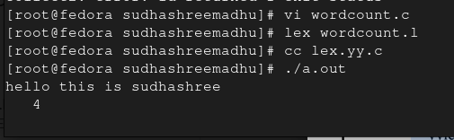

**RESULT:**